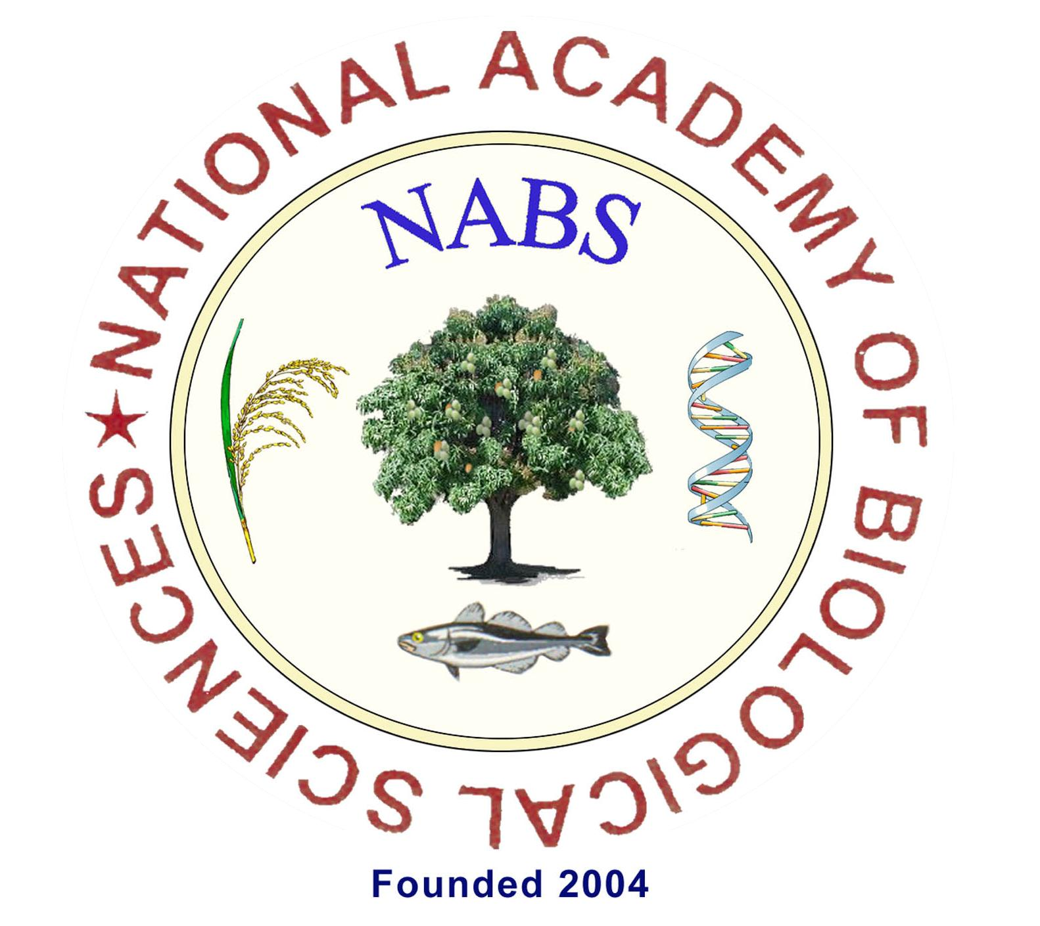
x
01Name in BLOCK Letters :02Date of birth (DD-MM-YYYY) & Gender: 03Father / Mother name04Year of obtaining Master's degree in biological Sciences & Specialization. :a. Institution /University in which Ph.D.is registered: b. Subject:05Present Position and address with PIN:06Name and address of the Guide with signature:

Signature of the guide06a. Other communication detailsOfficeResidencePhone No. with country code:Mobile:E-mail:07Declaration by the ApplicantI am willing to become a Provisional Life Member of NSBS. I shall abide by the bye-laws of the Academy and shall serve for the cause of NABS. I understand that the membership fee is not refundable.a. Provisional Life Membership (one time):Rs. 7,500/- or US$ 100/-08Details of payment mode (only online)Details of Payment madea.Name of Account: National Academy of Biological SciencesOnline Reference: b.Account No.: 10496978637 (Savings)Date of transfer:c.IFSC Code:SBIN0006463Bank’s name: d.State Bank of India, Anna University branch, AU college Campus, Sardar Patel Road, Guindy, Chennai- 600 025Place & Br. code:Have you provided evidence for transfer?Yes 09Signature of applicant with date
For Office Use onlyMail your application as soft copy [only in word format] to:
Prof. T. Marimuthu, Secretary, NABS
E-mail: secretarynabs@gmail.com
Note: Only type written application is acceptedReceipt No. :Date::Date of admission:Membership No.:Admitted Note: Any change in the present address should be communicated to the Secretary of the Academy

Secretary, NABS
National Academy of Biological Sciences
[NABS]
Application for Provisional Life Membership
Affix PP size photo

